

ICC CODES - PUBLIC COMMENT FORM

FOR PUBLIC COMMENTS ON THE 2013 REPORT

OF THE PUBLIC HEARINGS ON THE 2012 EDITIONS OF:

Administrative Provisions© (ADM)
International Energy Conservation Code©
- Commercial Energy (CE)
- Residential Energy (RE)
International Existing Building Code© (EB)
International Fire Code© (F)
ICC Performance Code© (PC)
International Residential Code©
- Building (RB)
- Mechanical (RM)
- Plumbing (RP)
International Property Maintenance Code© (PM)
International Swimming Pool and Spa Code© (SP)
International Wildland-Urban Interface Code© (WUIC)

CLOSING DATE: All Comments Must Be Received by: July 15, 2013

1) Please type or print clearly: Public comments will be returned if they contain unreadable information.

Name: | Glenn Mathewson, MCP |  |  |  |  | Date: | 6/25/13
Jurisdiction/Company: |  | City of Westminster, Colorado
Submitted on Behalf of: |  | North American Deck and Railing Association
Address: | 6417 Lee Street
City: | Arvada |  | State: | Colorado | Zip +4: |  | 80004
Phone: | 303-217-1351 |  | Ext: |  | Fax:
e-mail: | glennmathewson@nadra.org or glenn@glennmathewson.com

2) Copyright Release: In accordance with Council Policy #28 Code Development, all Code Change Proposals, Floor Modifications and Public Comments are required to include a copyright release. A copy of the copyright release form is included at the end of this form. Please follow the directions on the form. This form as well as an alternative release form can also be downloaded from the ICC website at www.iccsafe.org. If you have previously executed the copyright release, please check the box below:
x 2012-2014 Cycle copyright release on file

3) Code Change Proposal Number:
Indicate the Code Change Proposal Number that is being addressed by this Public Comment: RB6-13

4) Public Comment: The Final Action requested on this Code Change Proposal is: (Check Box)

 |  | Approved as Submitted (AS): |  |  |  | Approved as Modified by this Public Comment (AMPC): |  |  |  | Approved as Modified by the Code Committee as Published in the ROH (AM): |  |  |  | Approved as Modified by Assembly Floor Action as Published in the ROH (AMF): |  | x |  | Disapproved (D):

Attached Proposed Modifications and/or Reason Statements: YES

See Attached Individual Consideration Form

INDIVIDUAL CONSIDERATION FORM

RB6-13
R105.2

Individual Consideration Agenda

This item is on the agenda for individual consideration because a public comment was submitted.

Public Comment:

Name: Glenn Mathewson, Representing the North American Deck and Railing Association

Disapprove the code change proposal.

Commenter’s Reason:
The proponents reason statement fails to recognize all the hazards associated with deck construction. Homeowners relying on guidance from box stores or TV shows are misled into construction practices that are hazardous to their wellbeing and to the longevity of their property. The larger the deck, the more occupants it carries and the greater the probability of someone getting hurt. As a deck gets larger, so usually does its interface with the home. With this comes a greater likelihood that commonly overlooked hazards will occur. Decks constructed over emergency escape and rescue opening windows, over cat. IV appliance vents, ledgers blocking brick weepholes and foundation vents, decks under low overhead service cables, stairs near glazing, clearances at dryer exhaust vents, combustion air intake openings, and electrical service equipment working clearances…these are all subject to code violations from a poorly designed deck. With any regulation, a line has to be drawn. Why 30” of height, not 29”? Why 200 sf and not 210 sf? A line has to be drawn somewhere, 200 SF seems fair.

As for the connection to the house, poorly flashed connections will cause damage to the structure of the home. Exterior claddings such as stucco, adhered and anchored veneers, EIFS and vinyl siding must be appropriately handled when a deck is connected.

Pictures tell a thousand words.

This category IV appliance vent was going to be buried under this deck, as was the 24” egress window well for the basement of the house (note: constructed prior to 1994 UBC when 24” was the minimum).

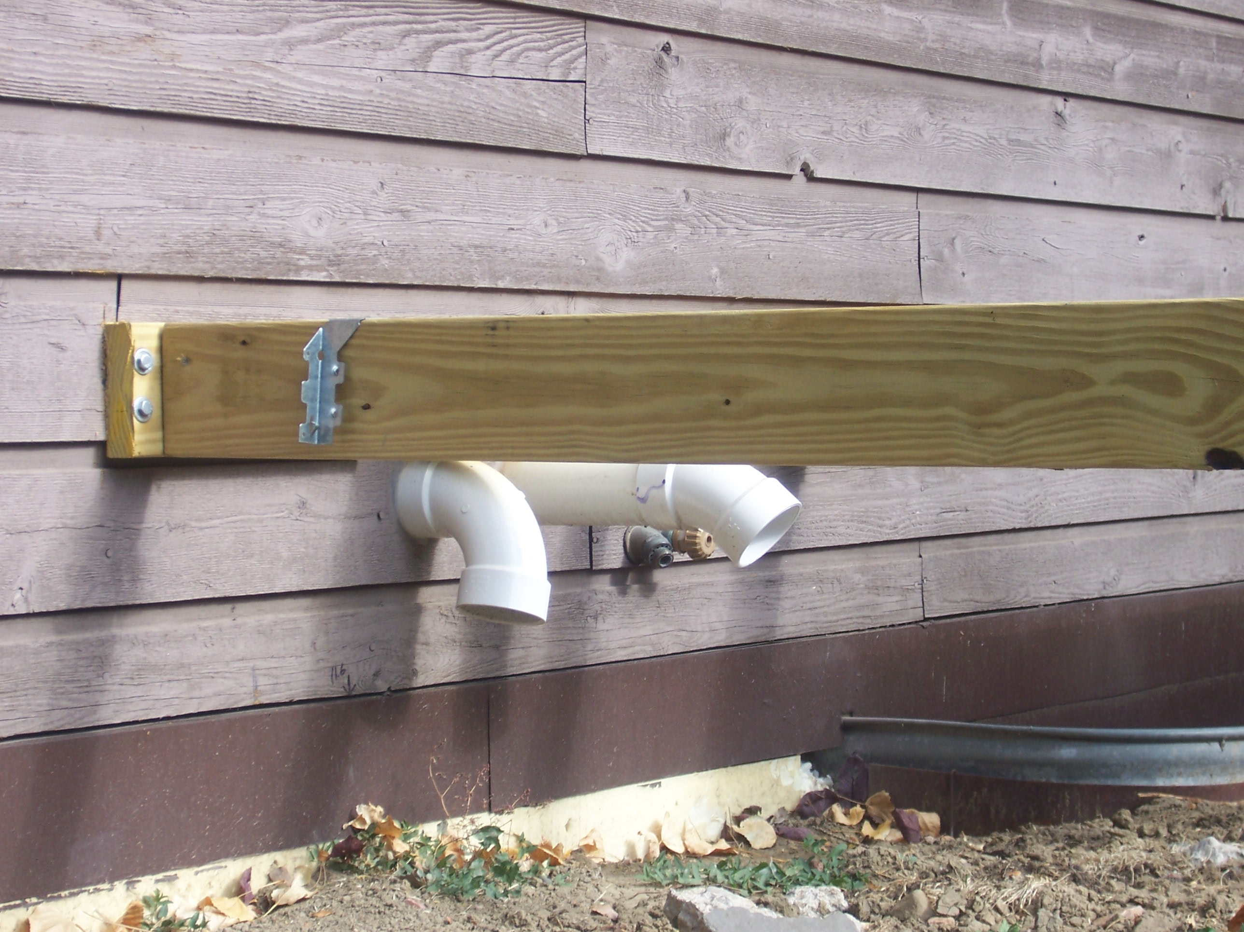

The contactor attached it over siding with no flashing, and buried the siding with about eight inches of dirt excavated from the piers.

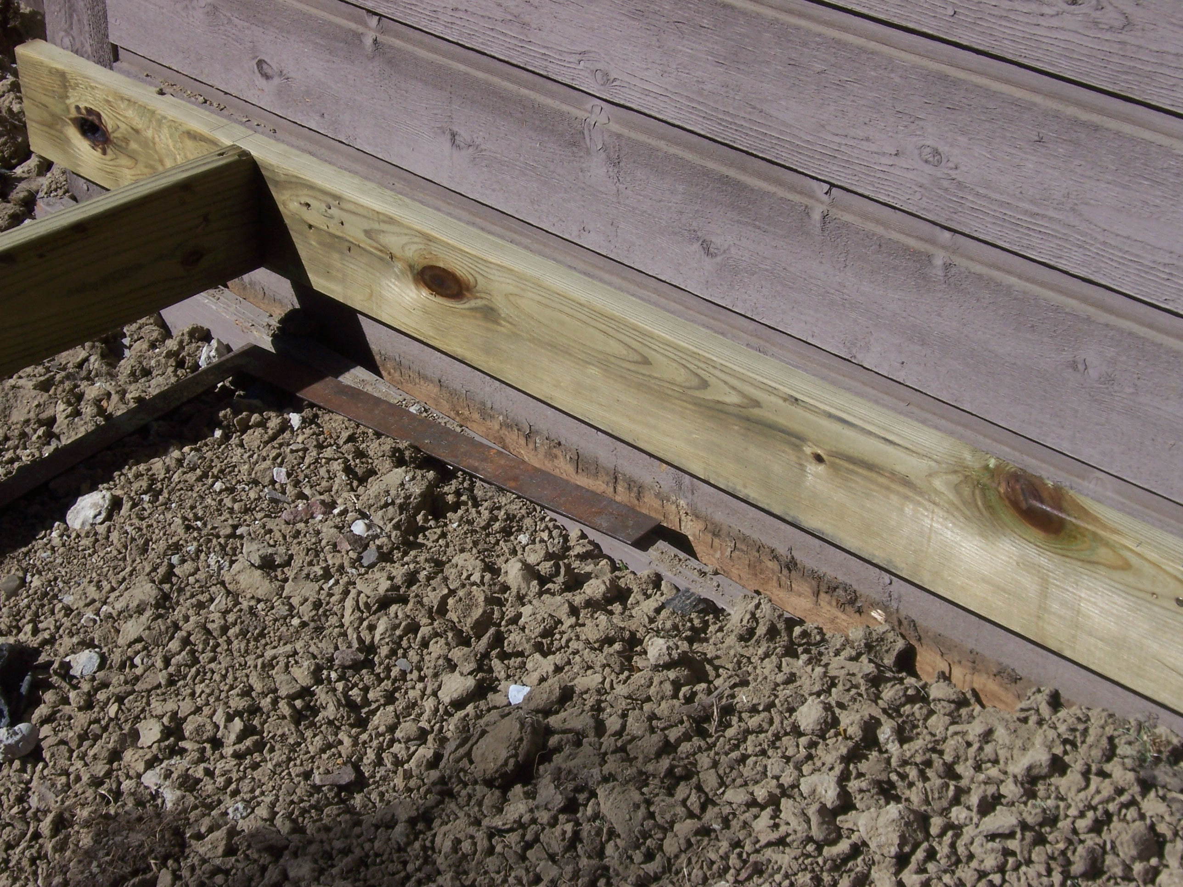

The IRC requires dryer vent terminations to be in accordance with the manufacturer, and they all require a minimum clearance. This ground-level deck prohibited operation of half the dryer vent louvers and was not provided the required clearances. The hood cannot be replaced without removing decking.

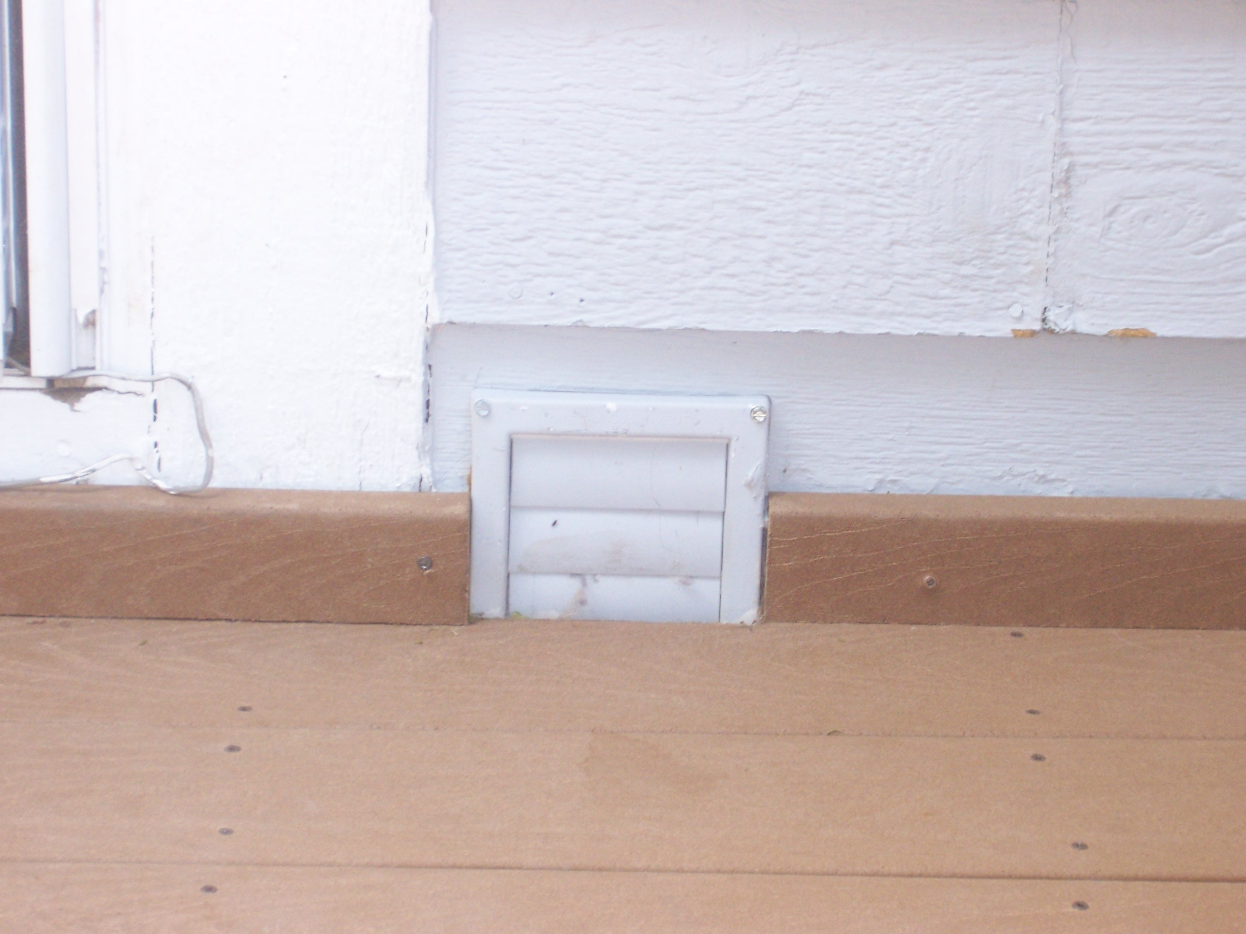

“Hazardous locations” are commonly created by the construction of decks. The larger the deck, the more windows it will likely meet. These windows require safety glazing due to the deck design, and I hope someone makes sure that combustion air hood below the deck is getting air (left of window).

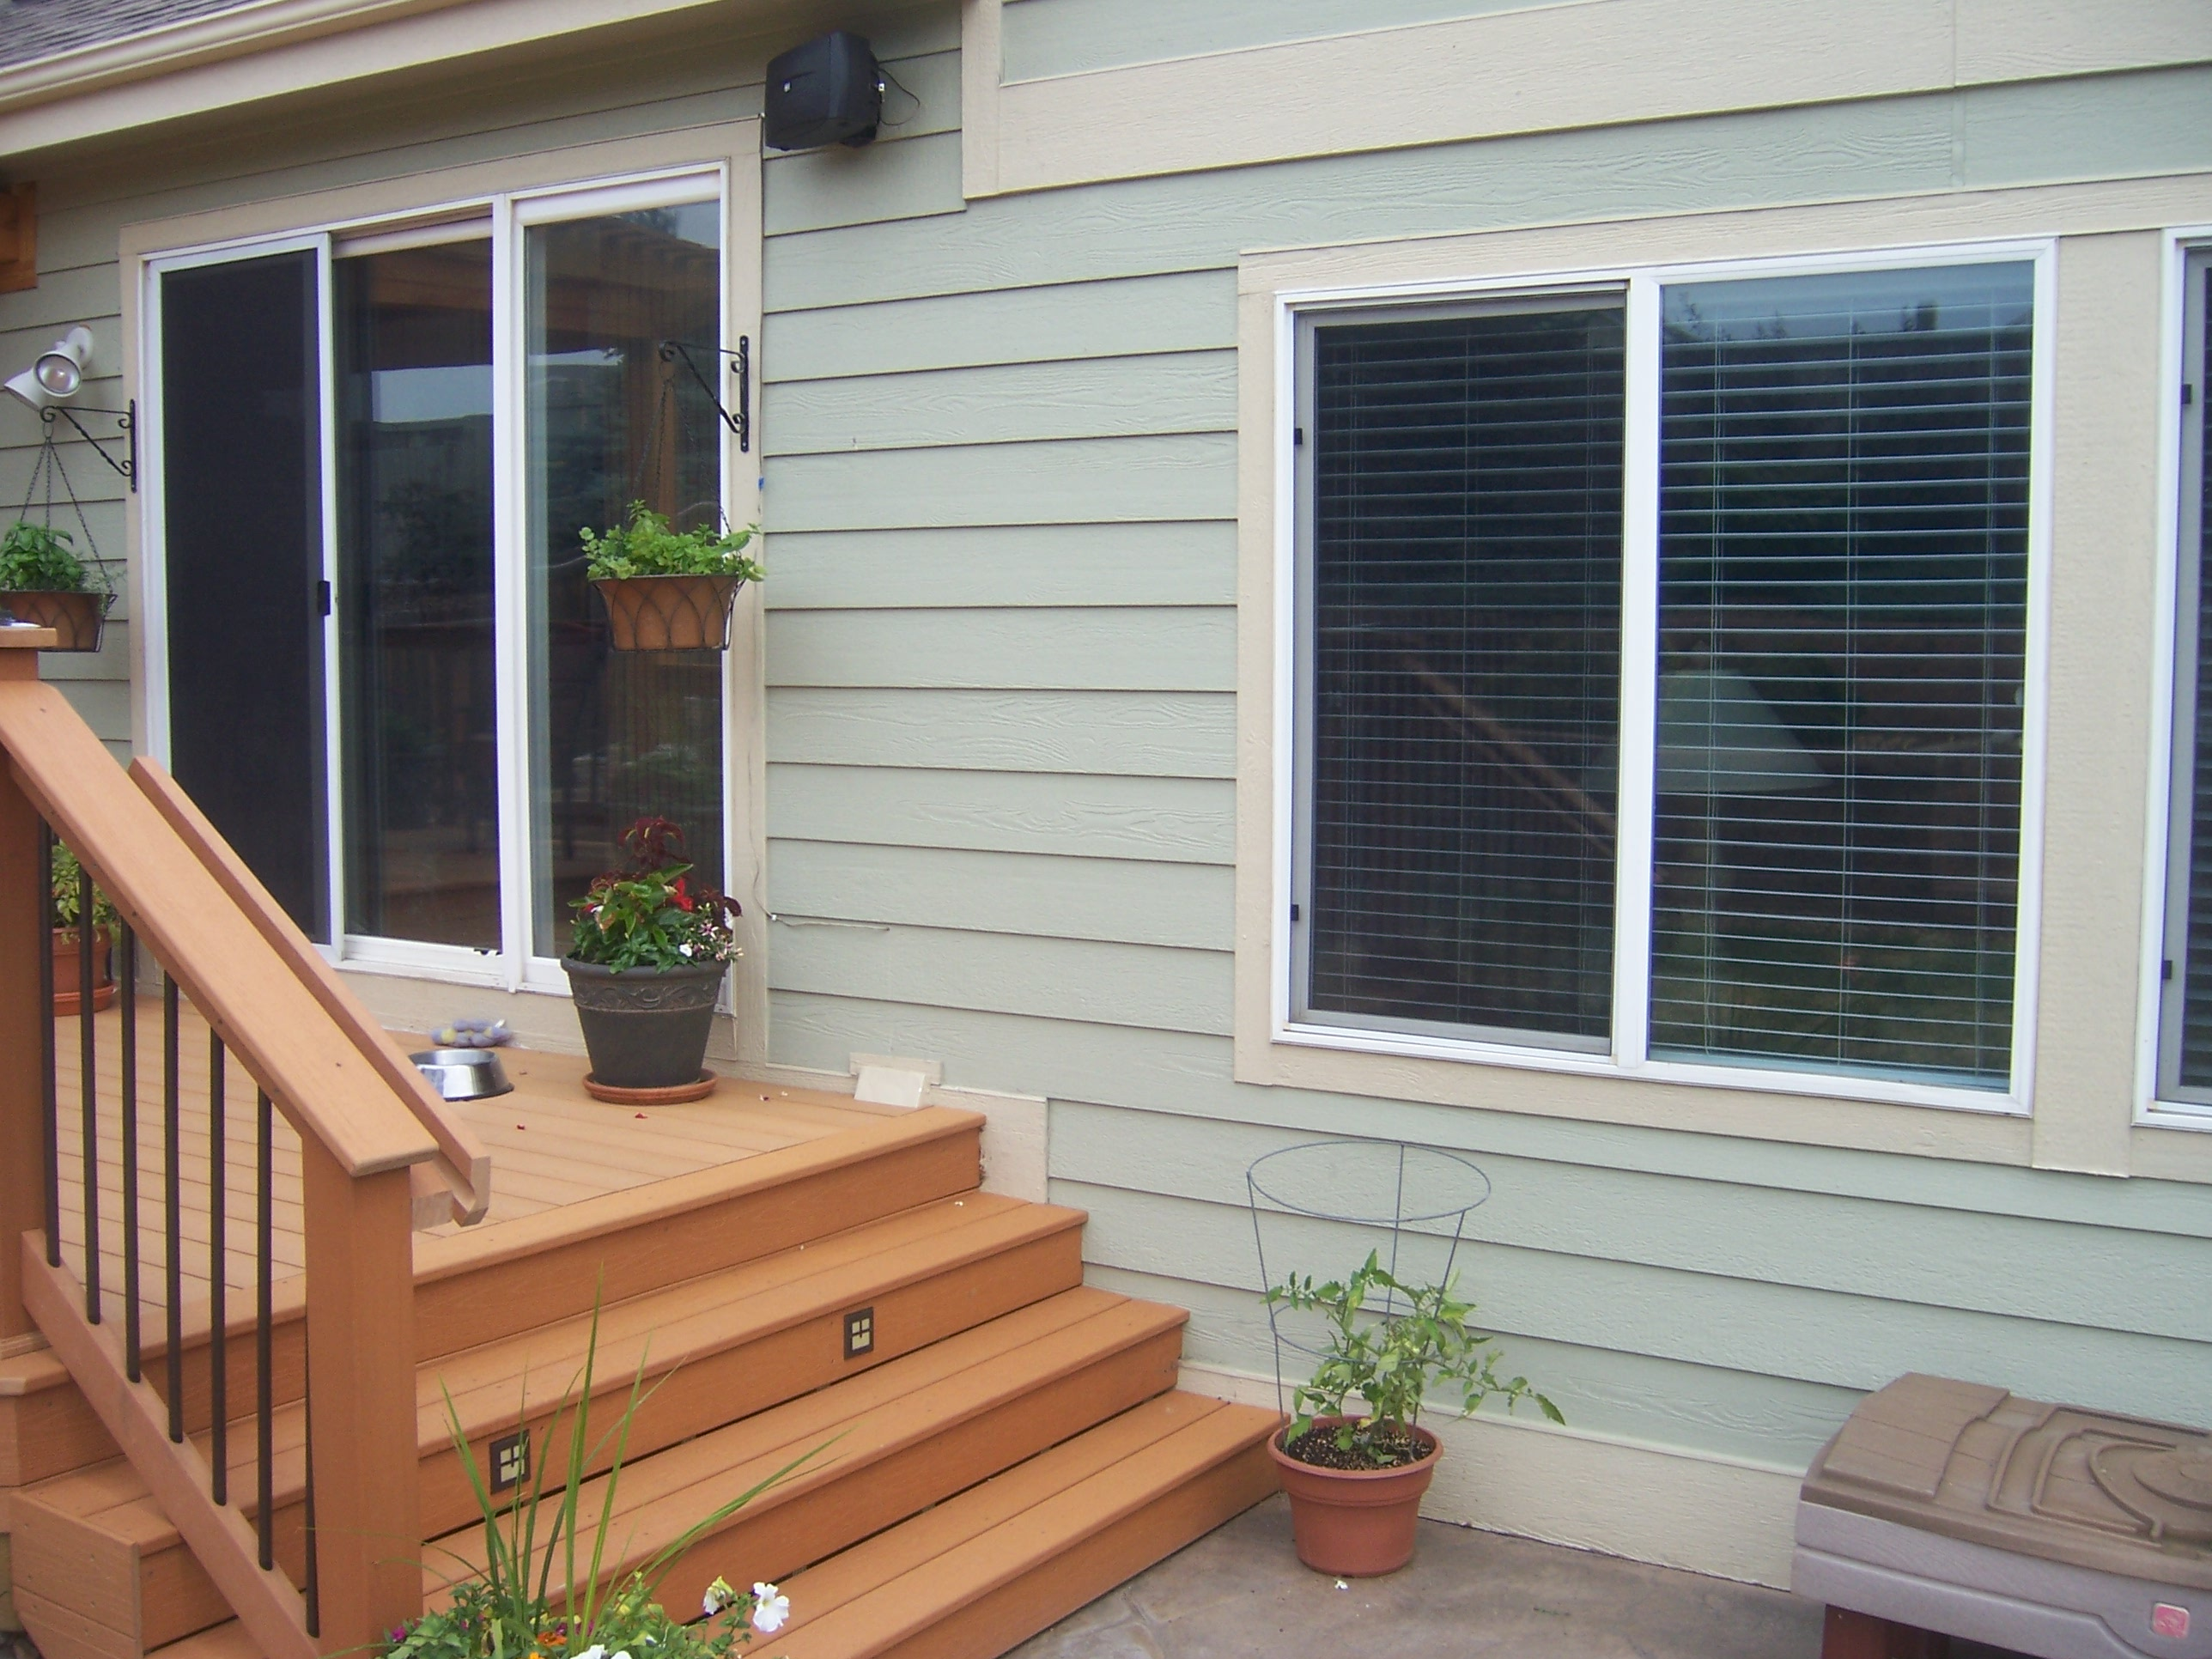

The size of the deck does matter when you are measuring the linear feet of destruction to the house’s rim joist and framing… (Note: this deck was more than 30” above grade, but the purpose of the picture is still valid. Bad decks ruin homes. Smaller bad decks ruin less of a home.). We should maintain the size limitation to provide balance between building small, detached, freestanding decks without permit hassle and those of unlimited size and connected to the house.



